Chapter 13, Problem 74.

Consider the three-phase transformer shown in Fig. 13.135. The primary is fed by a three-phase source with line voltage of 2.4 kV rms, while the secondary supplies a three-phase 120-kW balanced load at pf of 0.8. Determine:

(a) the type of transformer connections,

(b) the values of I_{LS} and I_{PS},

(c) the values of I_{LP} and I_{PP},

(d) the kVA rating of each phase of the transformer.

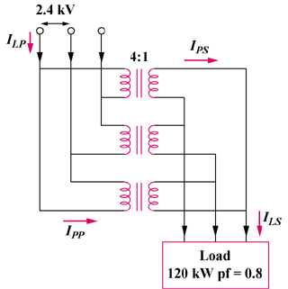

Figure 13.135
For Prob. 13.74.

